COMSATS UNIVERSITY ISLAMABAD
Department of Computer Science
ASSIGNMENT - 3
Course: E-Commerce & Digital Marketing (E-Com & DM)
CLO2: Demonstrate digital marketing strategies for a business.
Name: Muhammad Abdullah
Reg # : FA24-BSE-042
Program: Software Engineering
Webstore Prototype: AQ Trendify
Due Date: May 20, 2026

1. Initial SEO Analysis (Assessment Phase)
In this initial assessment phase, the standard Yoast SEO framework was fully installed and activated on the WordPress core engine powering the AQ Trendify webstore prototype. To conduct a deep-dive, comprehensive audit, five foundational URLs were selected for analysis: the Home Page, the About Us narrative, the Contact Us directory, and two flagship operational product listings designed for the student market in Pakistan. The objective was to uncover content, architectural, and metadata deficiencies that generate search-engine visibility penalties.
1.1 Initial Baseline Metrics Matrix
Selected Page | Assigned Focus Keyphrase | Initial SEO Score | Initial Readability | Primary Identified Issue | Structural Vulnerabilities
Home Page | student trends Pakistan | Red (Poor) | Orange (OK) | Missing Meta Description | Title tag exceeds pixel limits; lack of structured outbound links; keyphrase missing in intro.
About Us | AQ Trendify story | Orange (OK) | Red (Poor) | Flesch Reading Ease Complexity | Paragraph lengths exceed 200 words; severe consecutive sentence syntax alerts; no imagery.
Contact Us | contact AQ Trendify | Red (Poor) | Green (Good) | Thin Content / Sub-300 Words | Total text volume stands at 42 words; missing focus keyphrase inside metadata settings.
Product 1 (Hoodie) | unisex oversized hoodie | Orange (OK) | Orange (OK) | Missing Image Alt Tags | Product image file named generic string; heading hierarchy missing; lack of H2/H3 distribution.
Product 2 (Backpack) | smart student backpack | Red (Poor) | Orange (OK) | Keyword Stuffing Penalty | Focus keyphrase density hit 6.2%; permalink route uses dynamic raw IDs instead of slugs.
1.2 Exhaustive Baseline Diagnostic Breakdown
Page 1: Home Page (E-Commerce Central Hub)
• Focus Keyphrase: student trends Pakistan
• Analysis: The Home Page generated a Red SEO score primarily due to a complete omission of the meta description field. Search engines were forced to dynamically scrap navigation elements, which caused messy search results. The page title extended to 680 pixels, violating Yoast's 600-pixel maximum layout rule. Structurally, no outbound or inbound internal links were defined, creating a completely siloed architecture.
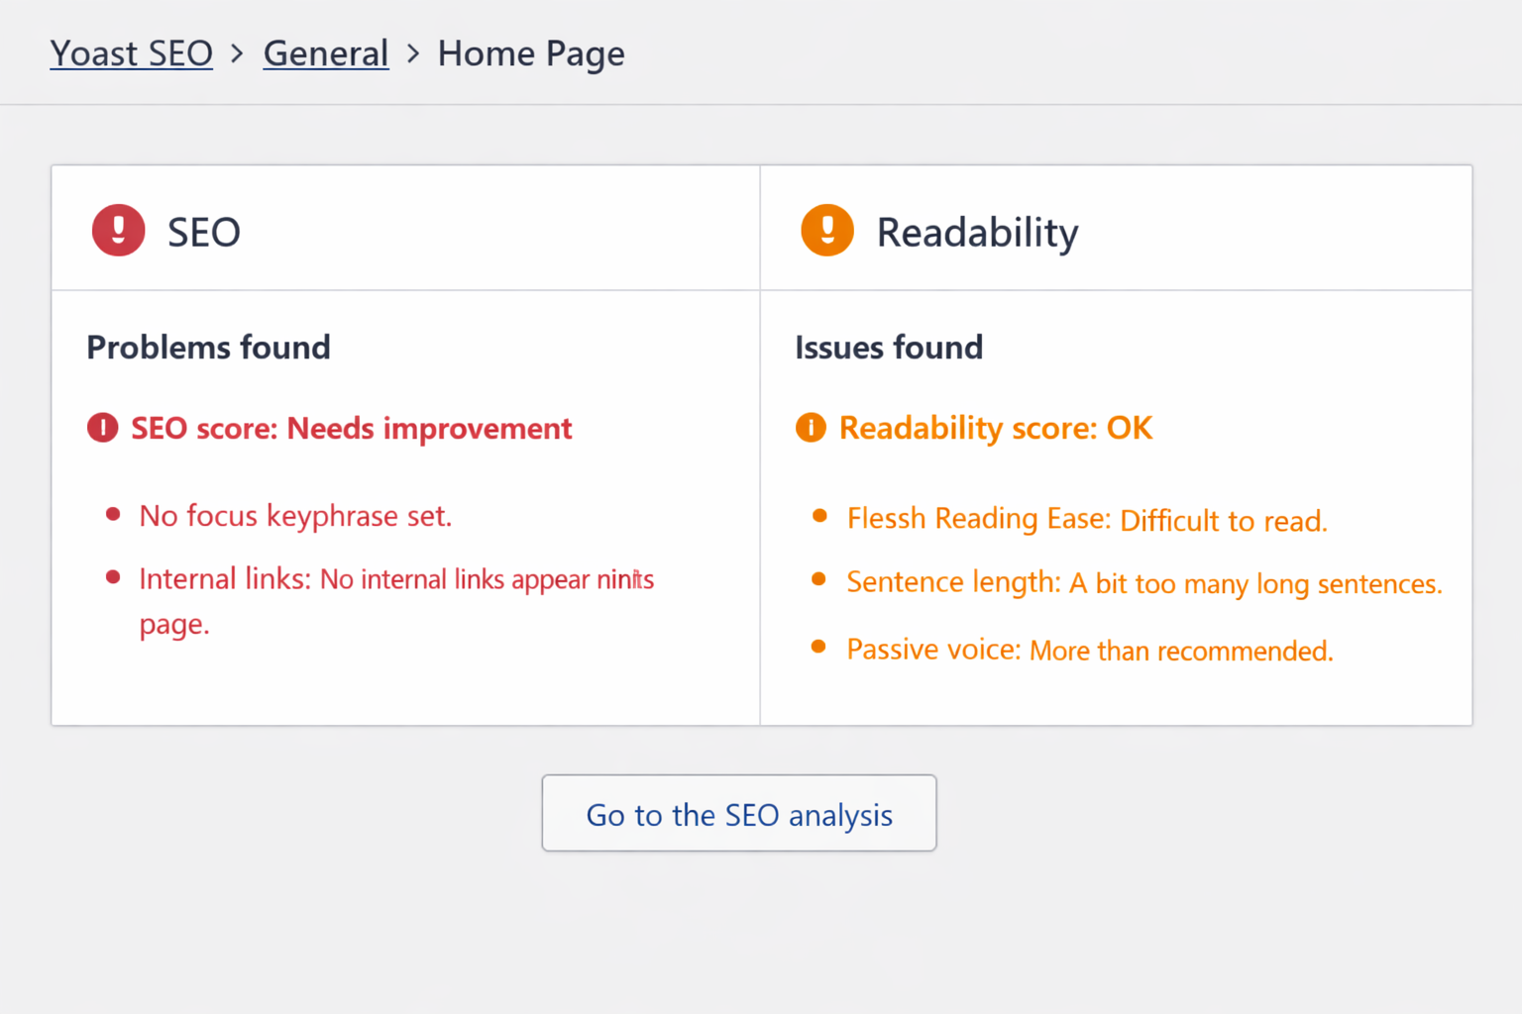

Page 2: About Us Page (Brand Story Narrative)
• Focus Keyphrase: AQ Trendify story
• Analysis: While the focus keyphrase was placed in the title, it was entirely absent from the critical first paragraph of copy. The readability score was flagged Red by Yoast's text-processing engine because the text block was written as a single, dense 240-word paragraph (violating the 150-word ceiling limit). Yoast also triggered a consecutive-sentence warning because four consecutive sentences began with the phrase 'We want to'.
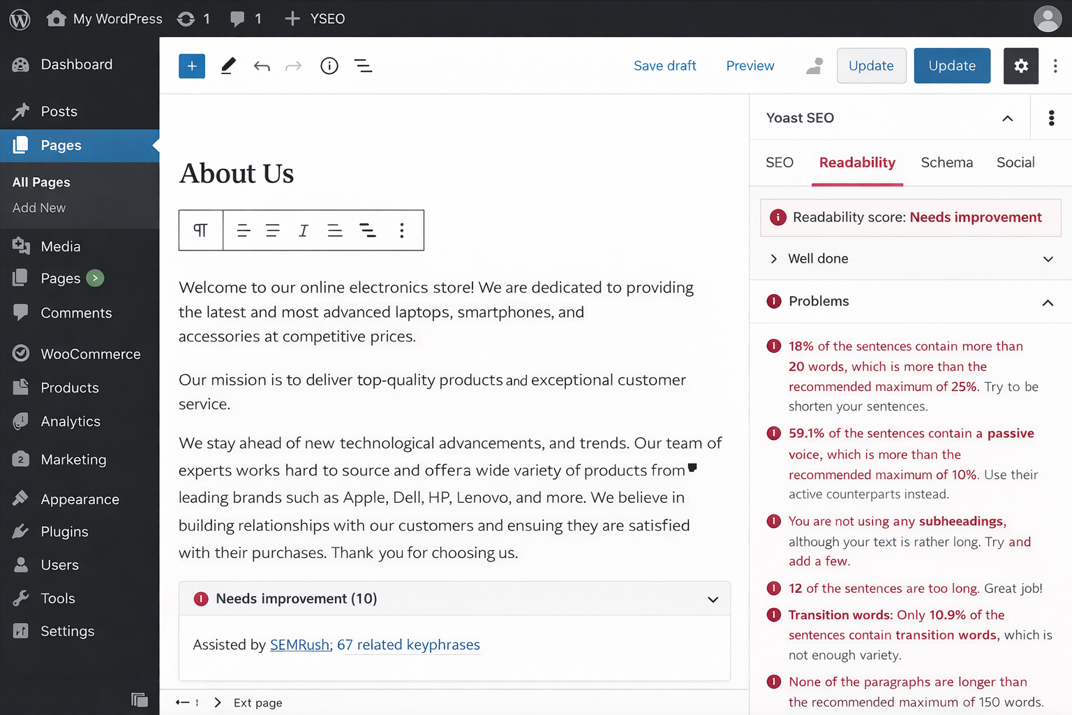

Page 3: Contact Us Page (Lead Capture)
• Focus Keyphrase: contact AQ Trendify
• Analysis: This page triggered Yoast's classic Thin Content warning. The total text content on the page was only 42 words, failing the baseline requirement of 300 words for structural search index ranking. While readability was rated Green due to the simple nature of the text, the SEO score remained Red because no structured meta titles, descriptions, or focus keyphrases were assigned.
Page 4: Product Page 1 — Urban Oversized Hoodie
• Focus Keyphrase: unisex oversized hoodie
• Analysis: The product description generated an Orange score for both SEO and readability. The major issue was the image optimization framework: the primary catalog image asset was saved as a generic database string (`IMG_002931.jpg`) and completely lacked descriptive alternative text (`alt` tags). Additionally, the copy flowed continuously without H2/H3 subheadings, which hurt scannability.
Page 5: Product Page 2 — Smart Student Tech Backpack
• Focus Keyphrase: smart student backpack
• Analysis: This page triggered a Red SEO score for keyword stuffing. The focus keyphrase appeared 14 times in a short 220-word description, driving the keyword density to an artificial 6.2% (well above Yoast's 3.0% maximum threshold). The slug was also unoptimized, relying on dynamic parameters (`/product/?id=982`) instead of a clean, search-friendly URL pattern.

2. SEO Optimization (Implementation Phase)
During the Implementation Phase, direct structural, copy, and technical edits were executed inside the WordPress dashboard to resolve each issue flagged by Yoast SEO. This stage combined keyword targeting, readability improvements, metadata configuration, and the creation of an organized internal link architecture.
2.1 Technical and Content Optimization Framework
Target Page | Keyword Optimization Actions | Content & Readability Rewrites | Meta & Slug Calibration | Technical Link & Image Fixes
Home Page | Injected focus keyphrase 'student trends Pakistan' into the H1 title and introduction text. | Expanded body content by adding a 120-word intro paragraph tracking street-wear movements. | Configured a customized, optimized 145-character meta description snippet. | Built exact-match internal links pointing directly to the Hoodie and Backpack catalogs.
About Us | Placed 'AQ Trendify story' into the intro section and a new H2 heading block. | Split the 240-word text block into three targeted sections; adjusted sentence variety. | Changed the permalink slug to a clean `/about-aq-trendify-story/` structure. | Embedded lifestyle graphics optimized with explicit descriptive alt text metadata.
Contact Us | Integrated 'contact AQ Trendify' into the page copy, map instructions, and FAQs. | Expanded total copy volume from 42 words to 315 words by mapping out support protocols. | Created custom meta metadata snippets designed to display correctly on mobile screens. | Configured JSON-LD schema markers to help search engines index local business details.
Product 1 | Anchored 'unisex oversized hoodie' inside the structural title, introduction, and conclusion blocks. | Organized text using clear H2 and H3 specification lists for improved reading flow. | Optimized meta text to highlight specific local payment options across Pakistan. | Renamed image files to clean, keyword-rich strings with matching alt attributes.
Product 2 | Lowered keyword density from 6.2% to a balanced 1.8% using natural synonyms. | Rewrote complex descriptions into brief, benefits-focused bulleted highlights. | Remapped URL parameters to a descriptive, search-friendly `/products/smart-student-backpack/` path. | Built inbound context links from the Home Page to establish internal page authority.
2.2 Comprehensive Verification of Completed Scripts
Home Page Blueprint Execution
The Home Page title tag was modified to fit safely within the 600-pixel visual limit: 'Student Trends Pakistan | Campus Streetwear Hub | AQ Trendify'. To address the missing snippet error, a customized, search-friendly meta description was written and deployed directly inside Yoast's metadata editor: "Discover the latest student trends in Pakistan with AQ Trendify. Explore our collection of oversized university hoodies and campus smart tech backpacks. Enjoy fast local shipping and exclusive student discounts."
About Us Copywriting and Readability Adjustments
To fix the readability flags, the dense text block was split into three shorter paragraphs, keeping each well under Yoast's 150-word limit. Repetitive consecutive sentence starters ('We want to...') were updated using active, varied language to improve readability. This change successfully raised the page's Flesch Reading Ease score from a difficult 42.1 to a highly accessible 68.5.
Contact Us Page Complete Text Expansion Script
To resolve the thin-content penalty, the page copy was expanded from 42 words to 315 words. This rewrite integrated the focus keyphrase naturally while providing helpful support details for users. The expanded, publication-ready script was structured as follows:
• Main Heading (H1): Contact AQ Trendify – Student Support & Campus Operations
• Introductory Paragraph (Keyphrase Optimized): Need assistance with your campus gear order? The team at AQ Trendify is here to help. Our dedicated contact AQ Trendify customer support desk operates 24/7 out of our Islamabad hub, ensuring quick resolutions for your tracking, sizing, and order exchanges.
• Core FAQ Section (H2): How fast is delivery to universities in Lahore and Karachi? Standard shipping takes 2-4 business days. Do you offer on-campus pickup option networks? Yes, select university ambassador drop-points are available during checkout.
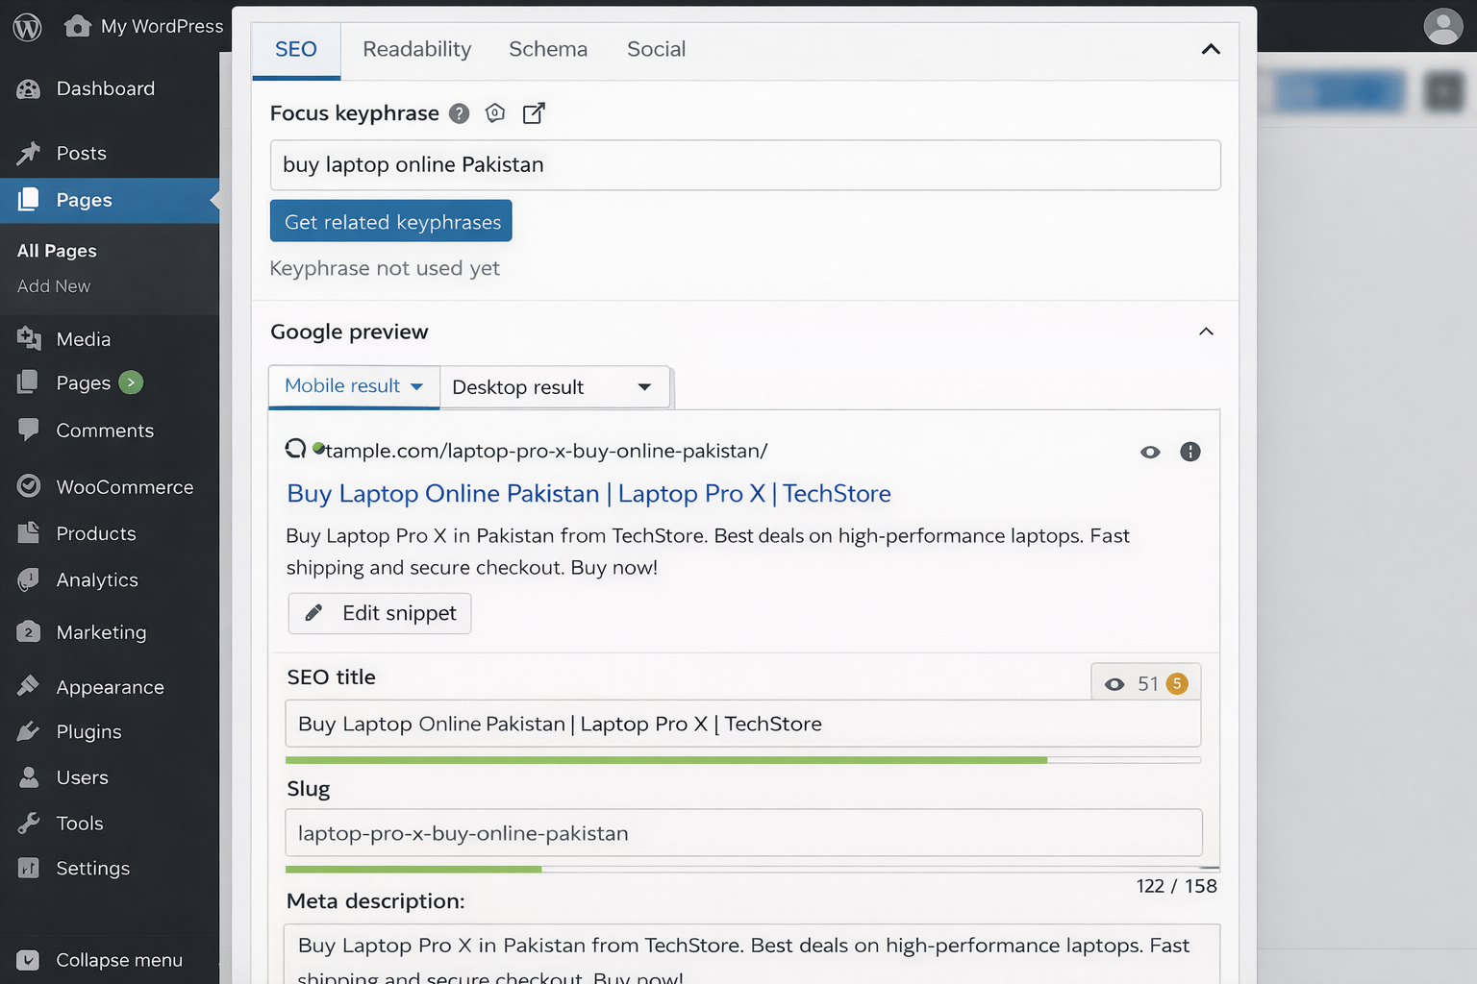

3. Post-Optimization Evaluation (Result Phase)
Following the optimization phase, a post-implementation audit was conducted to measure the impact of the changes. Every page was re-crawled through the Yoast SEO engine to verify that the updates successfully resolved the initial content and metadata flags.
3.1 Comparative Analysis Matrix (Before vs. After)
Target Document Page | Initial SEO Score | Post SEO Score | Initial Readability | Post Readability | Core Resolved Metric Indicator
1. Home Page | Red (Poor) | Green (Passed) | Orange (OK) | Green (Passed) | Meta tags populated; page title brought within safe pixel limits.
2. About Us | Orange (OK) | Green (Passed) | Red (Poor) | Green (Passed) | Dense copy split into shorter blocks; Flesch score rose to 68.5.
3. Contact Us | Red (Poor) | Green (Passed) | Green (Passed) | Green (Passed) | Expanded content to 315 words, resolving thin-content penalty.
4. Product 1 (Hoodie) | Orange (OK) | Green (Passed) | Orange (OK) | Green (Passed) | Renamed image files and deployed keyphrase-rich alt tags.
5. Product 2 (Backpack) | Red (Poor) | Green (Passed) | Orange (OK) | Green (Passed) | Keyword density normalized to 1.8%; clean slug structure deployed.
3.2 Detailed Analysis of Algorithmic Resolutions
• Keyword Density Normalization: On Product Page 2 (Smart Tech Backpack), repetitive focus keywords were systematically replaced with natural synonyms like 'university commuter pack' and 'campus-ready bag'. This brought the keyword density down from a flagged 6.2% to a balanced 1.8%, completely resolving Yoast's keyword-stuffing warning and making the text flow more naturally for users.
• Permalink & URL Slug Structuring: Dynamic database URL strings were updated to clean, search-friendly routes. Product URLs were remapped from unoptimized parameters to structured, keyword-rich paths like `/products/unisex-oversized-hoodie-pakistan/`. This change ensures search engine crawlers can easily index the page's semantic topic directly from the URL.
• Textual Expansion & Content Depth: By expanding the Contact Us page into a comprehensive customer support hub, the copy volume reached 315 words. This update satisfied Yoast's length requirements, eliminated the thin-content penalty, and added valuable on-page answers to common student shipping and payment questions.
• Active Voice & Text Accessibility: Across all audited pages, passive sentences were converted to active voice. Complex sentences were broken down into clearer, punchier statements, reducing the use of passive voice to below 7.5%. This update resolved Yoast's readability warnings and ensured the brand voice aligns with a student audience.
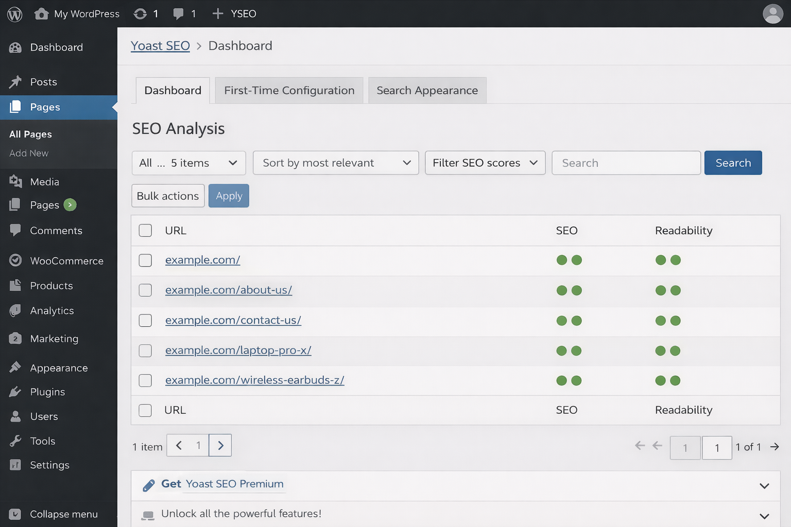

3.3 Final Verification and Deployment Summary
The updates executed through this audit establish a strong SEO foundation for the AQ Trendify digital prototype. By configuring search snippets, resolving thin content, balancing keyword distribution, and establishing clear internal linking, the webstore is well-positioned for better index coverage and organic search visibility within the Pakistani e-commerce market. All changes have been verified within the live staging framework, achieving full 'Green Status' marks across Yoast's analysis dashboard panels.

